Bitwarden Installation on Windows server 2022

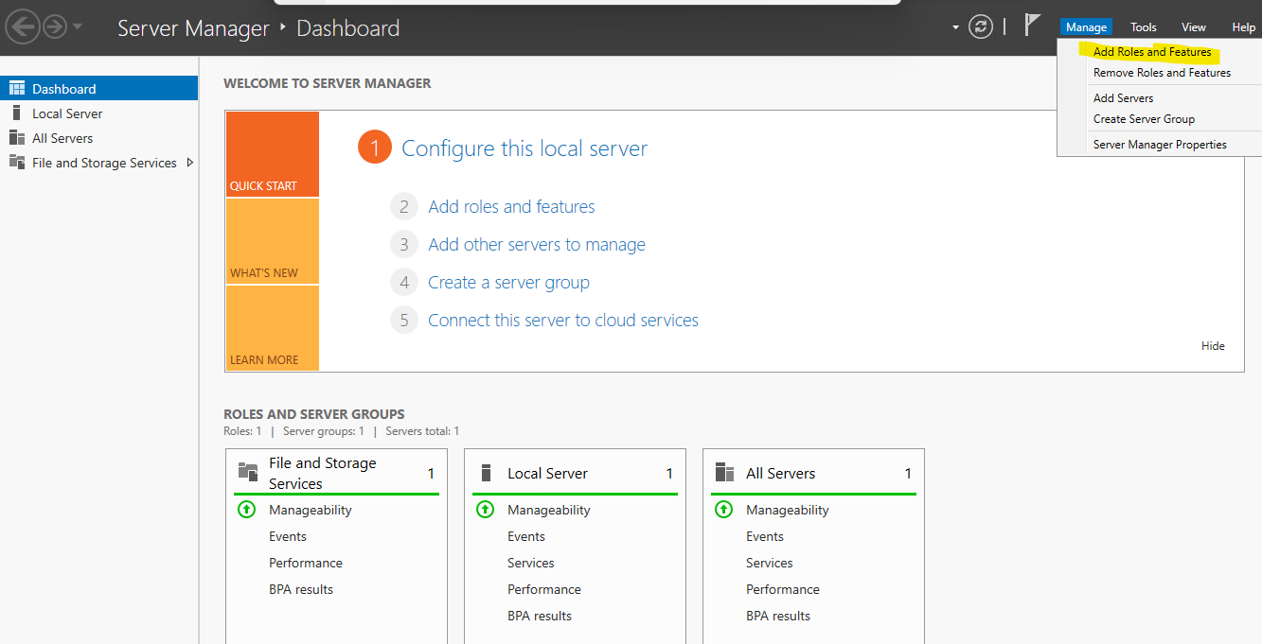

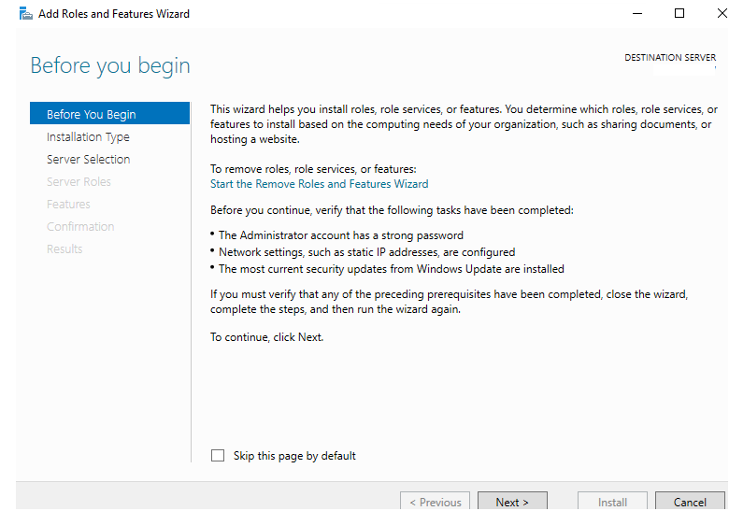

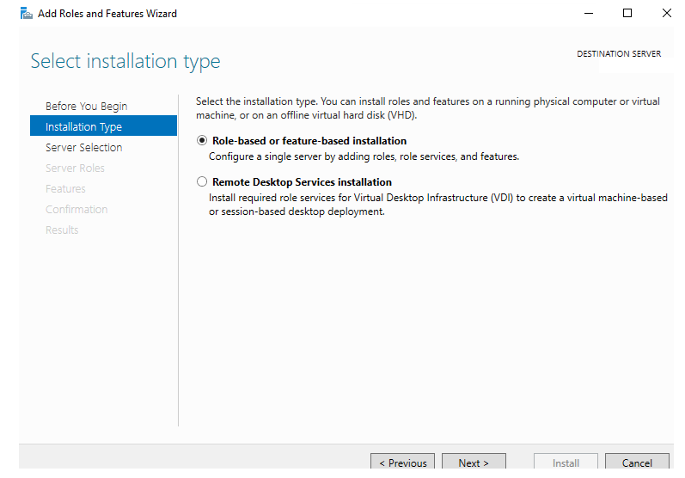

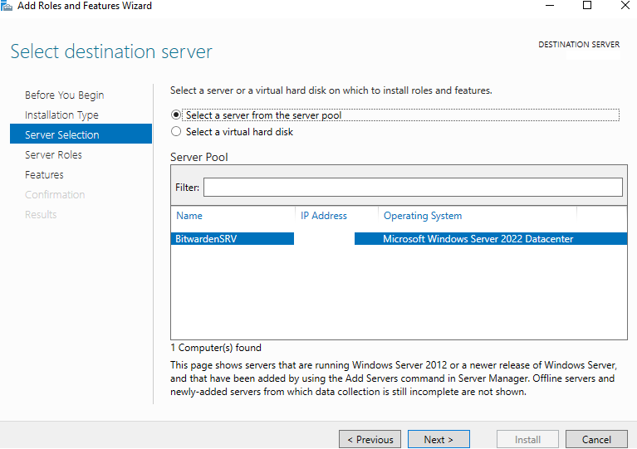

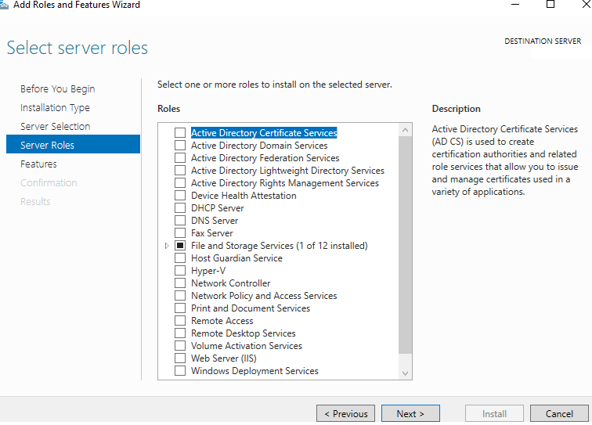

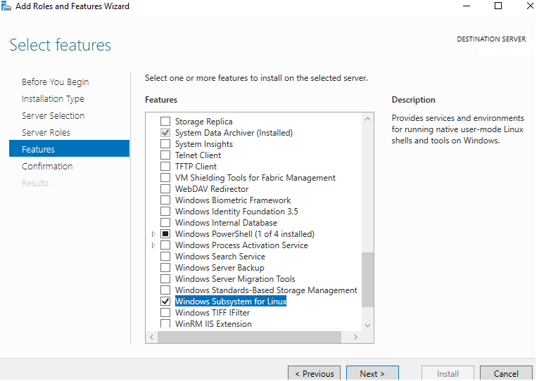

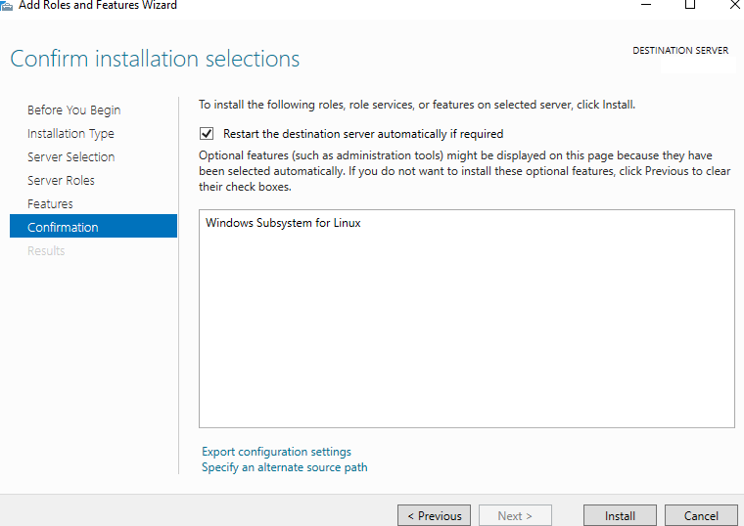

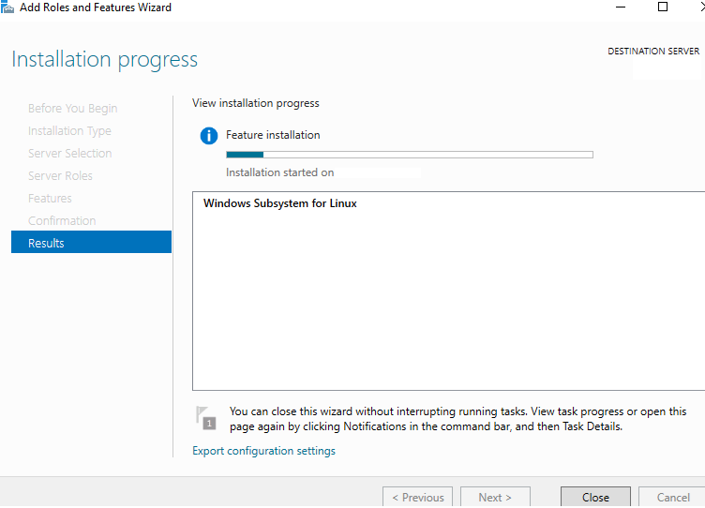

The system will reboot in between the process of Installing WSL

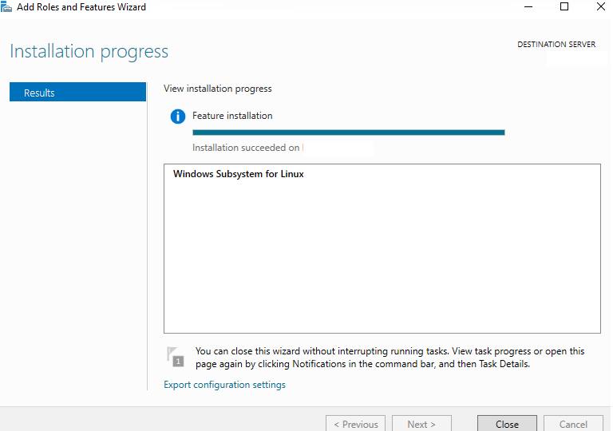

After Rebooted the server, Install the feature “Containers”, follow the same steps open Server Manager and select the option “Containers”

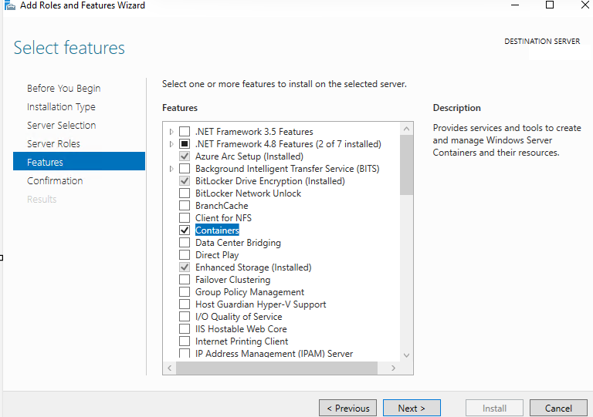

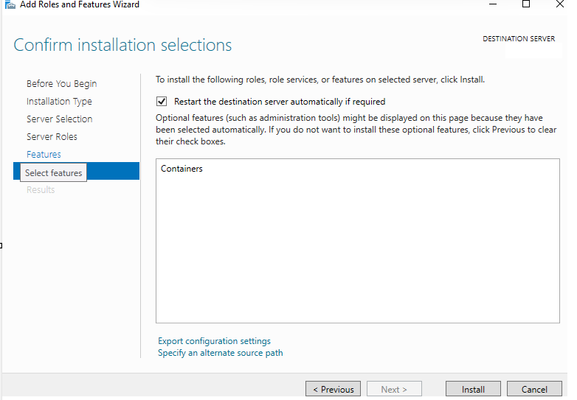

The server will reboot during enabling the feature “Containers”

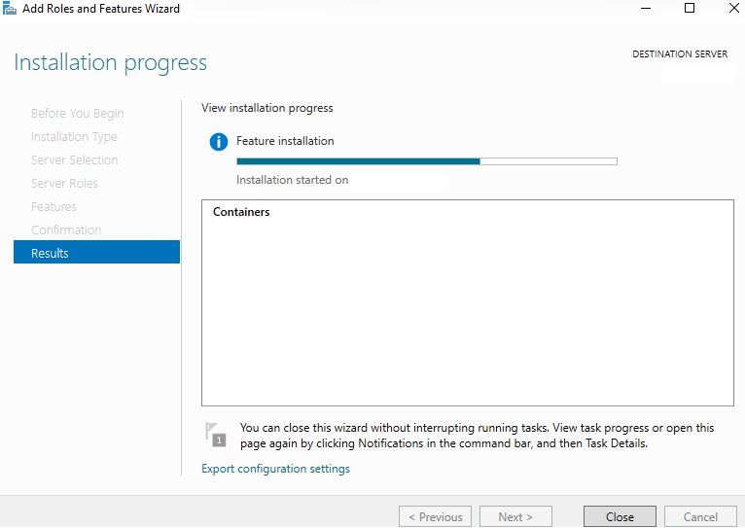

After rebooted the system

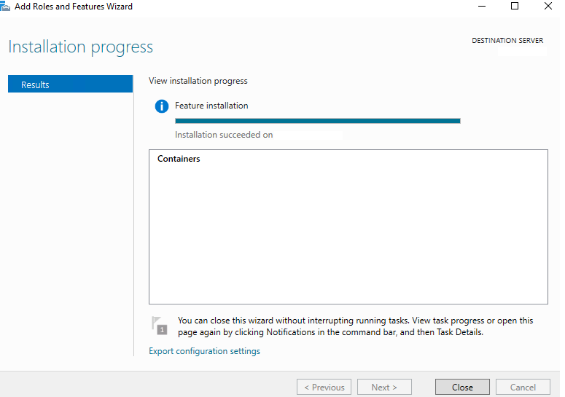

Enabling Ubuntu 20.04

Open PowerShell as Administrator

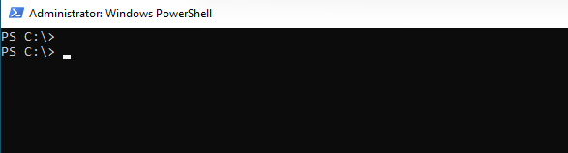

First to validate if Windows Subsystem for Linux has installed or not

wsl --list --verbose

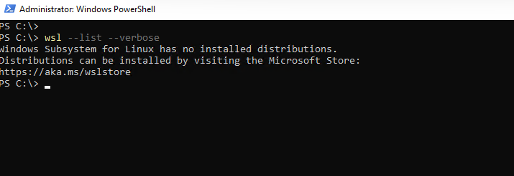

To verify if Virtual Machine Platform is enabled or disabled

Get-WindowsOptionalFeature -Online | Where-Object FeatureName -eq "VirtualMachinePlatform"

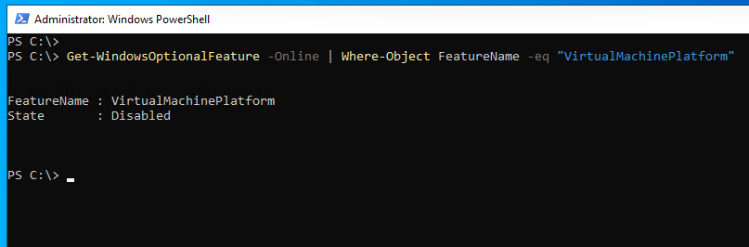

Enable-WindowsOptionalFeature -Online -FeatureName VirtualMachinePlatform -All

It will ask to press Y to confirm, once it press enter key, the system will reboot

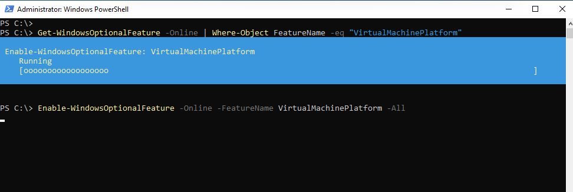

Now verify again if Virtual Machine Platform is enabled or disabled

Get-WindowsOptionalFeature -Online | Where-Object FeatureName -eq "VirtualMachinePlatform"

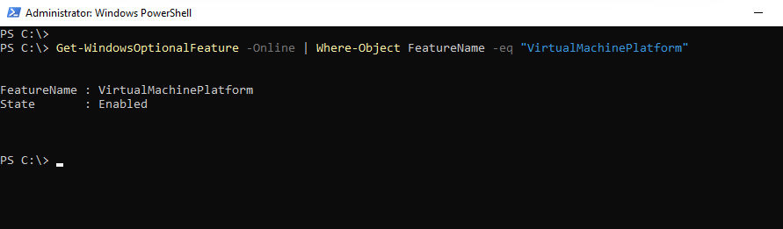

wsl --set-default-version 2

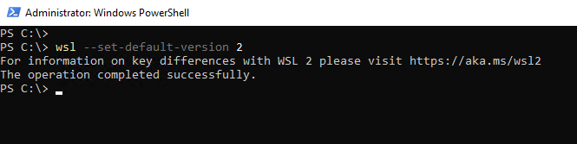

Now verify which Ubuntu versions are available to download

wsl.exe -l -o

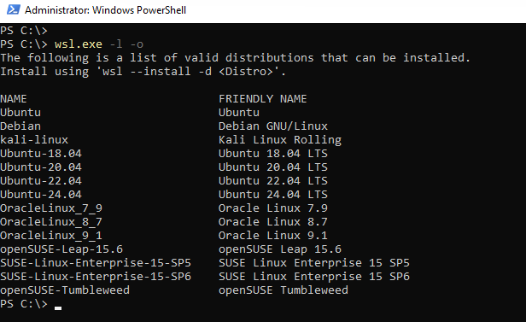

wsl --install -d Ubuntu-20.04

Set the username & password for WSL (Ubuntu 20.04)

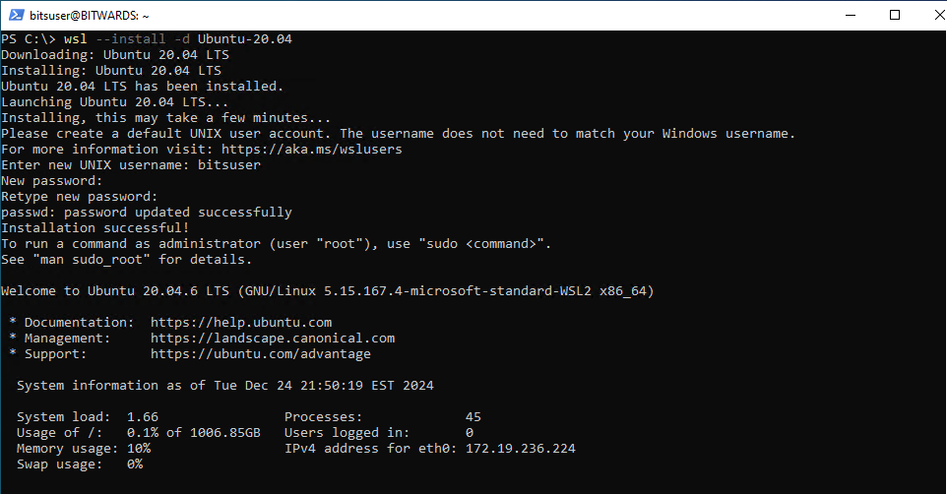

Reboot the System

After the rebooted the System, Ubuntu 20.04 LTS shows in the start menu, now we need to configure a username and password to access the Ubuntu 20.0.4 and Install Docker on top of it.

wsl --list --verbose

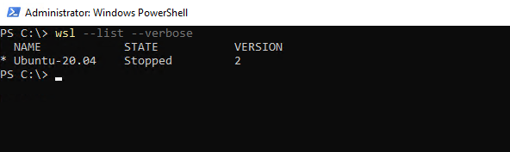

To start Ubuntu-20.04 click on Start select Ubuntu 20.0.4 LTS

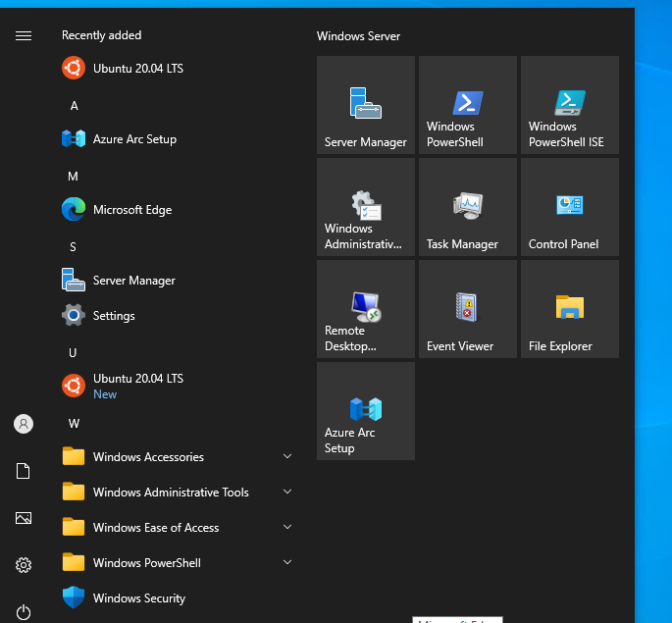

The Ubuntu instance is now running

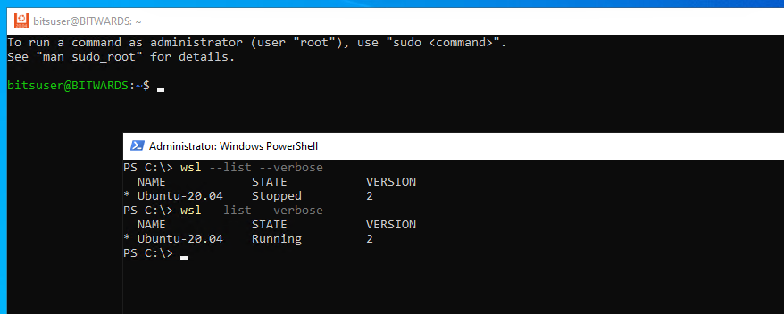

**Now Install Docker on Ubuntu 20.04**

**NOTES:**

Docker Desktop Edition doesn’t support Windows server 2019 & Windows server 2022

Docker Desktop has a limitation to support Windows 8, Windows 10, Windows 11 Desktop editions.

**Reference URL:**

[Windows | Docker Docs](https://docs.docker.com/desktop/setup/install/windows-install/#:~:text=Docker%20Desktop%20is%20not%20supported,Server%2C%20see%20Microsoft%27s%20official%20documentation%20.&text=To%20run%20Windows%20containers%2C%20you,11%20Professional%20or%20Enterprise%20edition.)

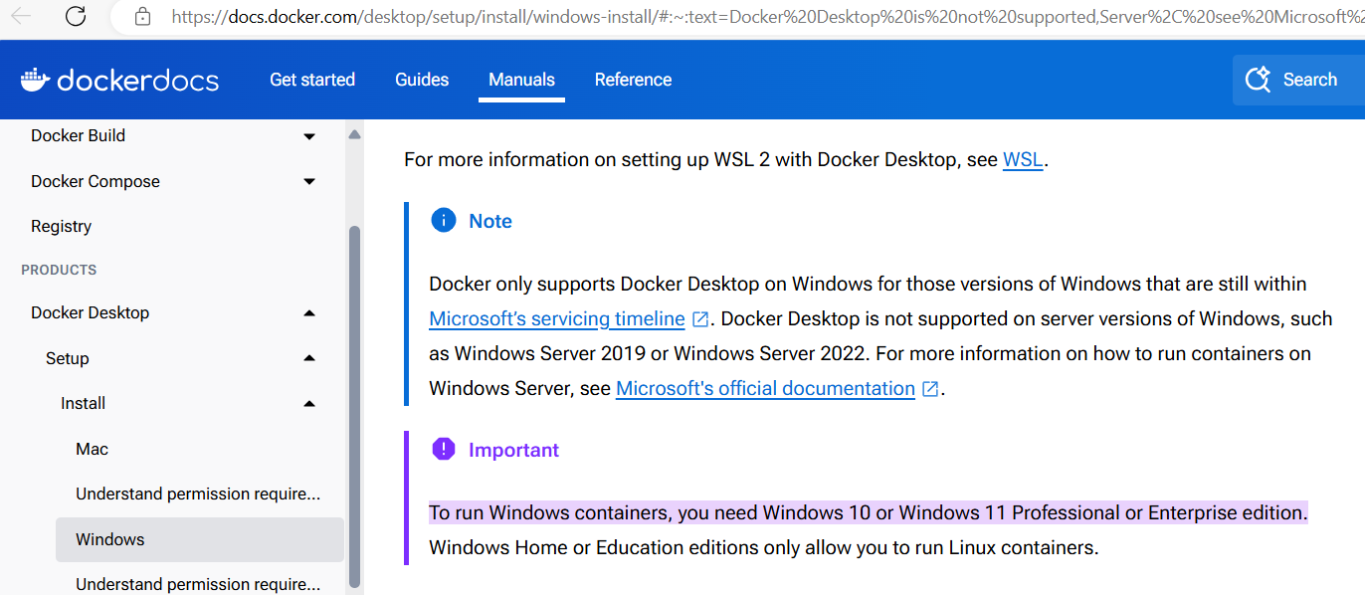

dism.exe /online /enable-feature /featurename:Microsoft-Windows-Subsystem-Linux /all /norestart

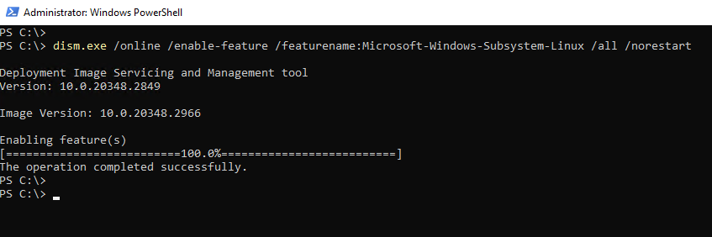

dism.exe /online /enable-feature /featurename:VirtualMachinePlatform /all /norestart

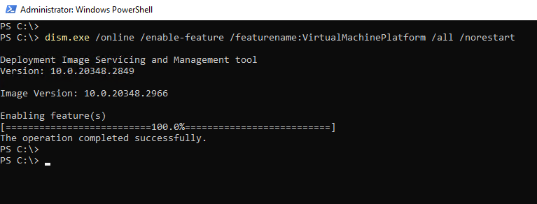

Reboot the System

After rebooted, Open PowerShell, update the wsl

wsl --update

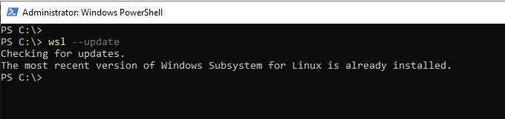

NOTE:

In case if the server Shutdown or Rebooted, make sure the WSL (Ubuntu 20.0.4) must be running first otherwise Docker and Bitwarden will not work

A Script is running in the background to startup the Windows Subsystem Linux (WSL) for Ubuntu 20.04 configured in the Task scheduler

Open the Notepad

wsl -d Ubuntu-20.04

Save the file name as “start-ubuntu.ps1” under “C:\scripts\start-ubuntu.ps1”

Open the Notedpad

# Define the action to run PowerShell with the script as an argument

$Action = New-ScheduledTaskAction -Execute "powershell.exe" -Argument "C:\scripts\start-ubuntu.ps1"

# Define the trigger to run the task at startup

$Trigger = New-ScheduledTaskTrigger -AtStartup

# Create the task object without adding unnecessary settings

$Task = New-ScheduledTask -Action $Action -Trigger $Trigger

# Register the scheduled task with the specified name

Register-ScheduledTask -TaskName "Start Ubuntu on Startup" -InputObject $Task

Save the file name as “wsl-run.ps1” under “C:\scripts\wsl-run.ps1”

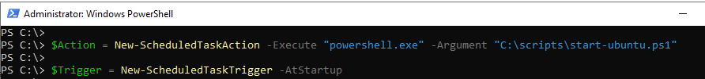

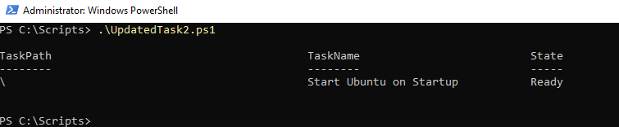

To switch over to Ubuntu 20.04 from PowerShell run the below command & it will take to the Ubuntu $ prompt

wsl -d Ubuntu-20.04

Before Install Docker Application make sure Bitwarden directory exists in the OS C:\ dirve

In this example: Create Bitwarden directory in the C:\

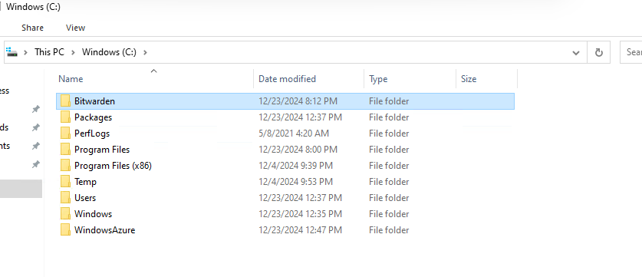

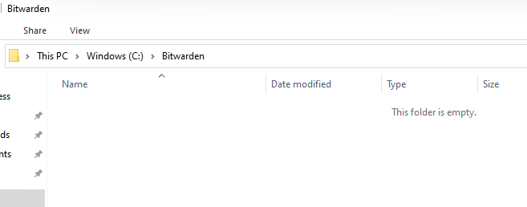

Now update the Ubuntu updates

sudo apt update -y

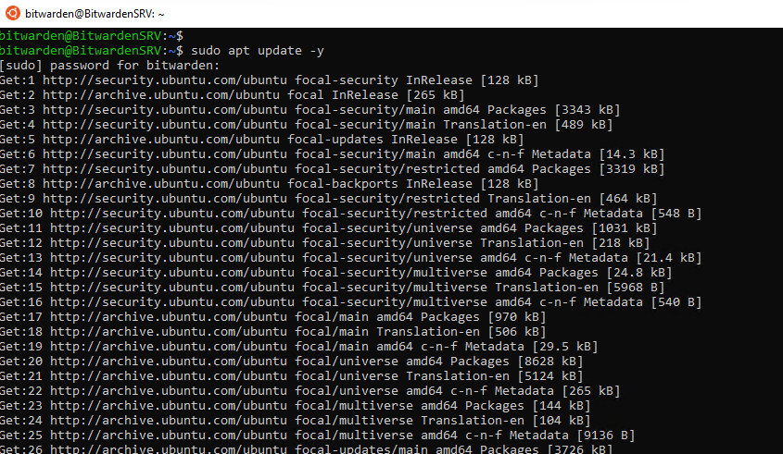

sudo apt upgrade -y

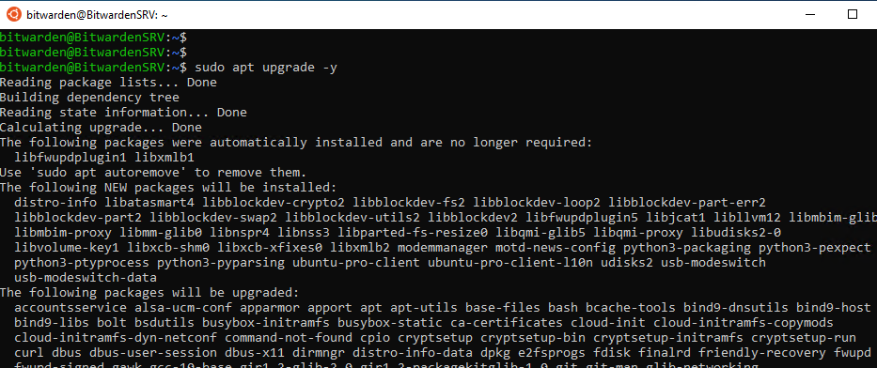

Reboot the Windows server 2022

Now we need to install Docker after rebooted the system, Run the 4 commands one by one

Switch over the system to Ubuntu by typing the below command

wsl -d Ubuntu-20.04

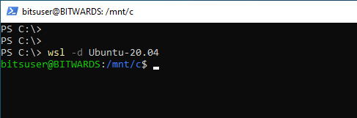

sudo apt install apt-transport-https ca-certificates curl software-properties-common -y

curl -fsSL https://download.docker.com/linux/ubuntu/gpg | sudo gpg --dearmor -o /usr/share/keyrings/docker-archive-keyring.gpg

echo "deb [arch=amd64 signed-by=/usr/share/keyrings/docker-archive-keyring.gpg] https://download.docker.com/linux/ubuntu $(lsb_release -cs) stable" | sudo tee /etc/apt/sources.list.d/docker.list > /dev/null

sudo apt update

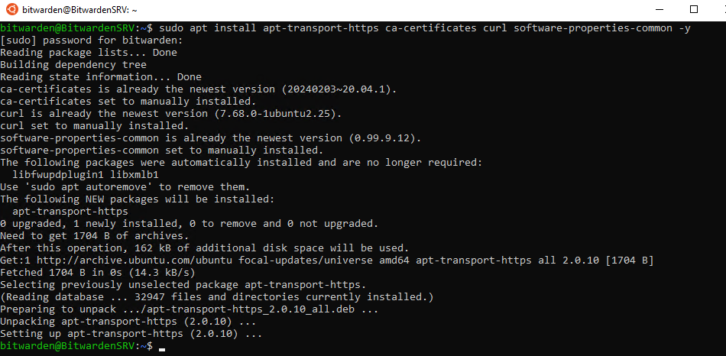

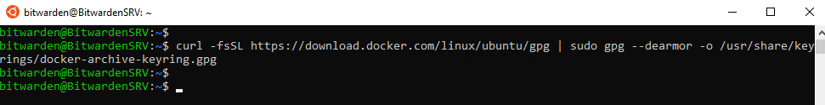



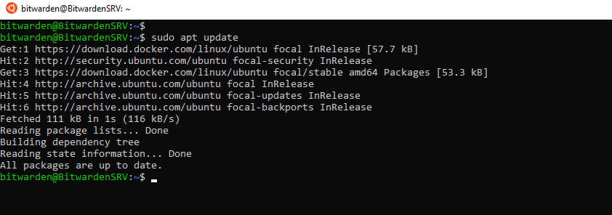

sudo apt install docker-ce docker-ce-cli containerd.io -y

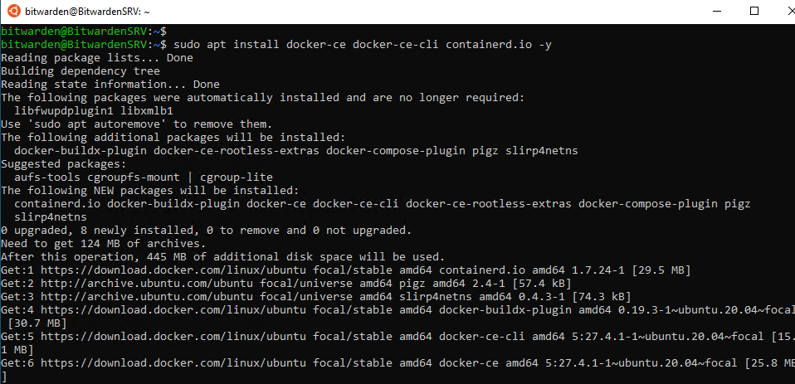

sudo service docker start

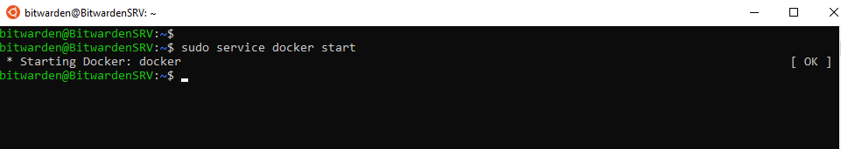

Sudo service docker status

Press q to exit

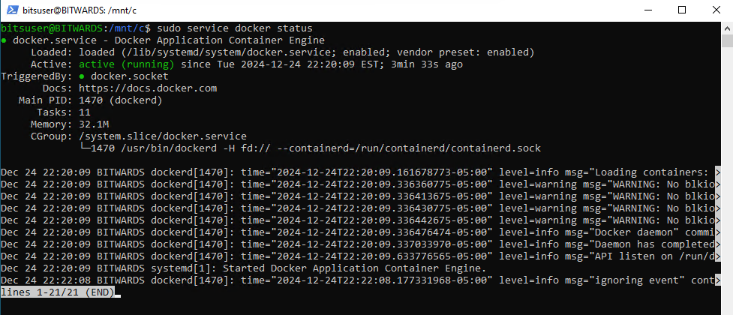

sudo systemctl enable docker

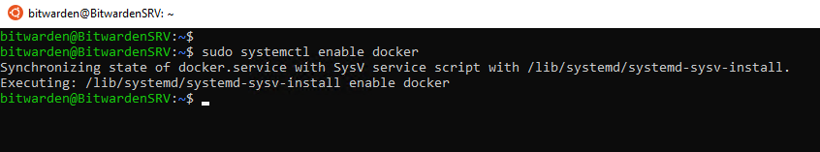

docker --version

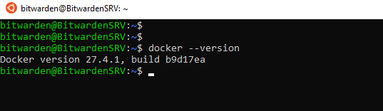

sudo usermod -aG docker $USER && newgrp docker

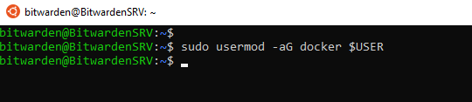

newgrp docker

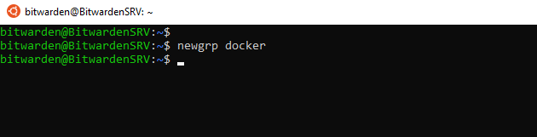

To check the docker images

docker images

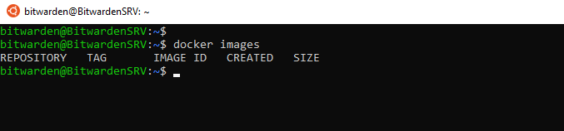

Now we will download & install the docker “hello-world” image from dockerhub to ensure docker is up & running.

sudo docker run hello-world

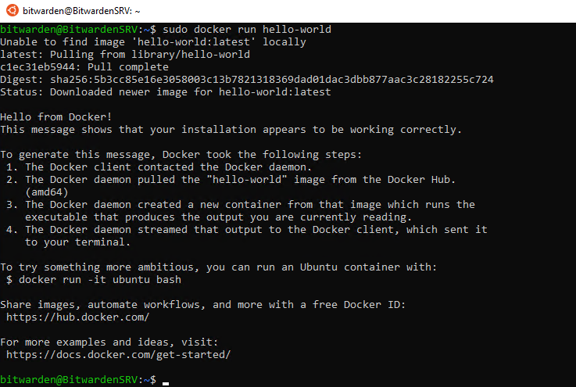

docker images

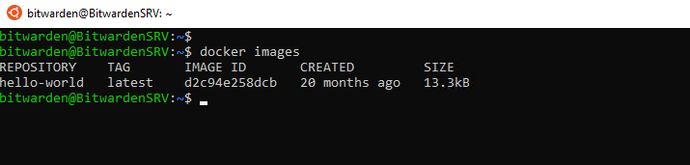

**Now install Docker compose**

docker-compose –version

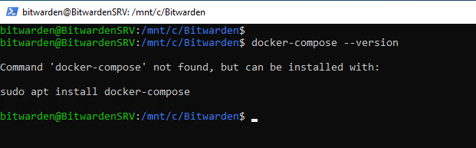

sudo curl -L "https://github.com/docker/compose/releases/download/1.29.2/docker-compose-$(uname -s)-$(uname -m)" -o /usr/local/bin/docker-compose

sudo chmod +x /usr/local/bin/docker-compose

docker-compose --version

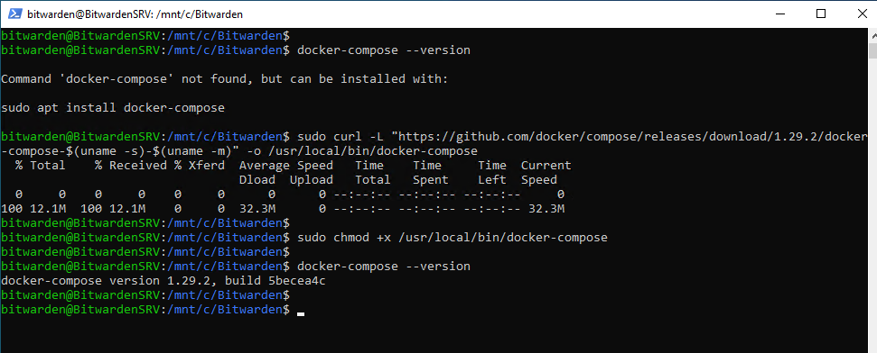

sudo apt install docker-compose -y

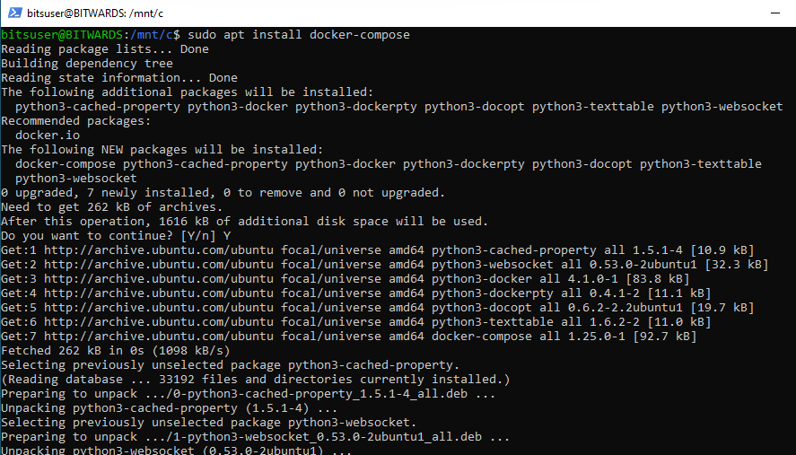

Reboot the System

<https://github.com/bitwarden/self-host/blob/main/bitwarden.sh>

Copy the contents of bitwarden.sh file in to the notepad and save the file under C:\Bitwarden\bitwarden.sh

Or alternative can download directly from the Bitwarden github repo

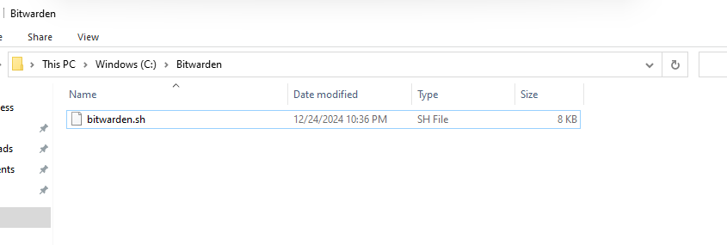

To switch over to WSL (Ubuntu 20.04) from PowerShell execute the following command, it will start the Ubuntu in the background and takes to the Ubuntu prompt

wsl -d Ubuntu-20.04

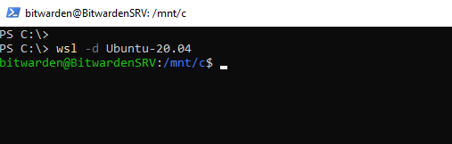

sudo chmod u+x bitwarden.sh

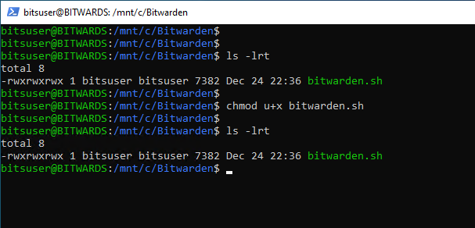

./bitwarden.sh

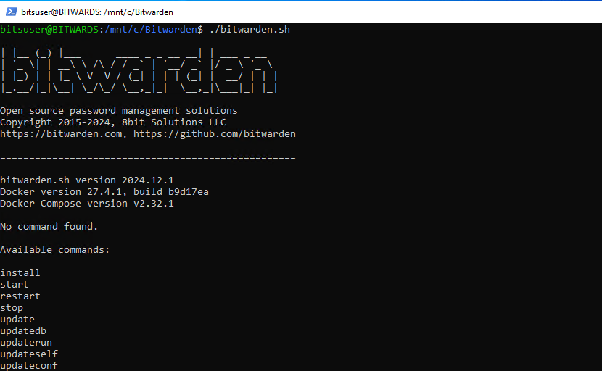

./bitwarden.sh install

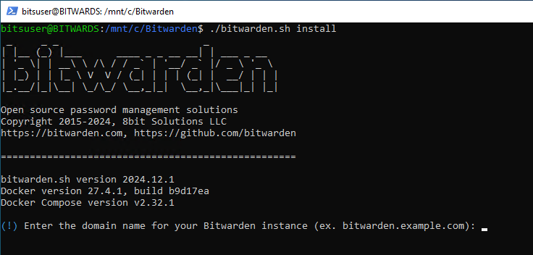

To get the installation ID & Key (region=US)

[Requesting Hosting Installation ID & Key | Bitwarden](https://bitwarden.com/host/)

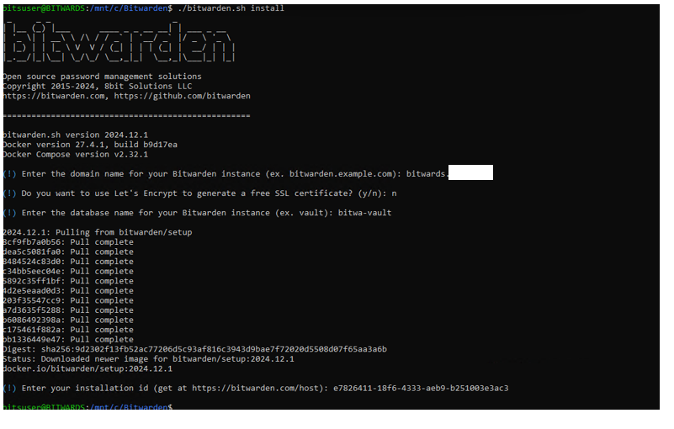

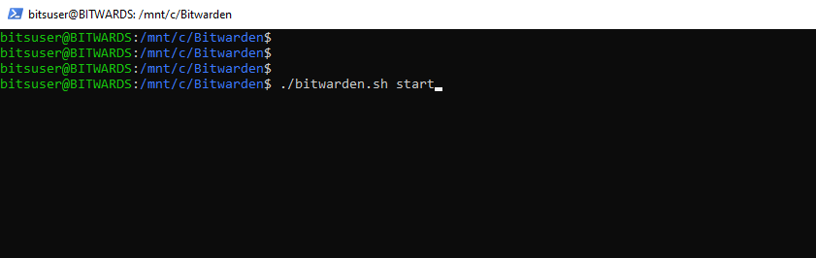

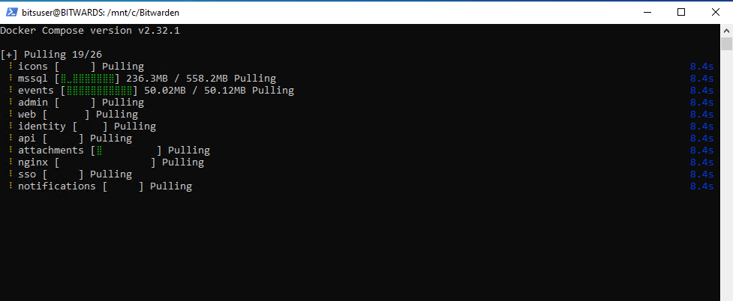

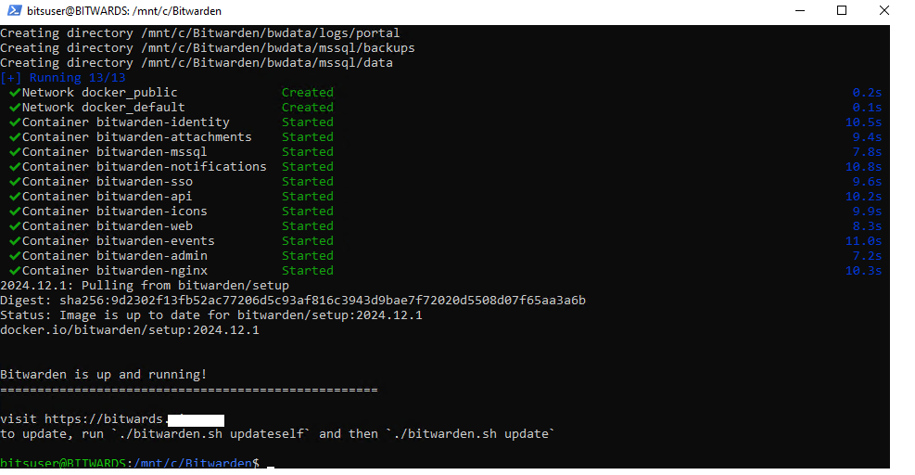

Now change the “global.override.env” file

It is located under “C:\Bitwarden\bwdata\env”

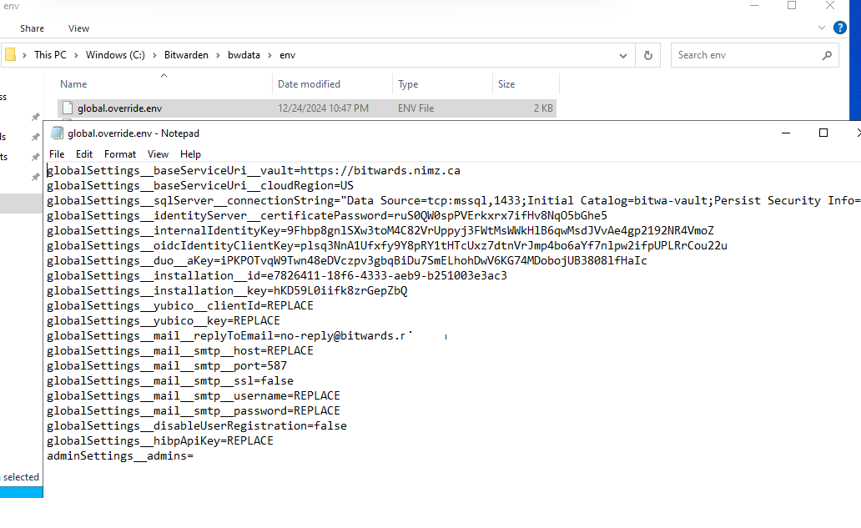

**Modify the below paramenters:**

globalSettings__mail__smtp__host=smtp.gmail.com

globalSettings__mail__smtp__username=xyz@gmail.com

globalSettings__mail__smtp__password=ktrt hqev rlho waev

globalSettings__hibpApiKey=""

adminSettings__admins=xyz@gmail.com

./bitwarden.sh stop

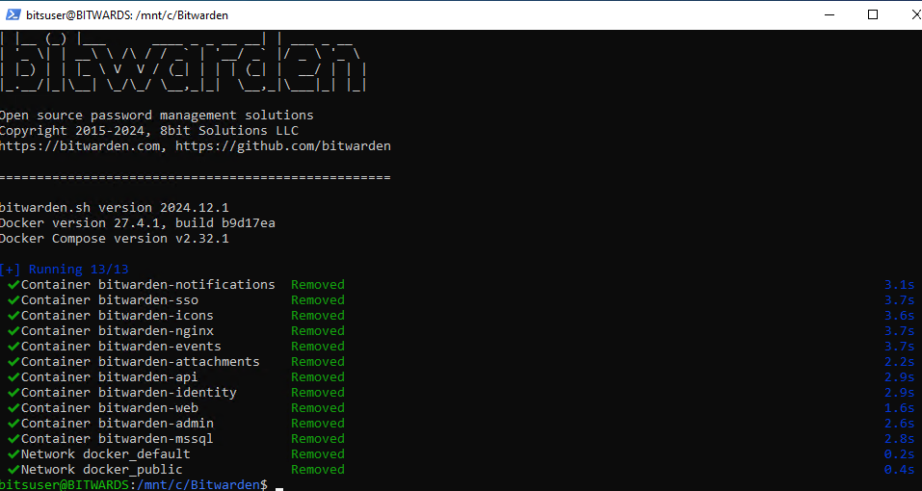

./bitwarden.sh start

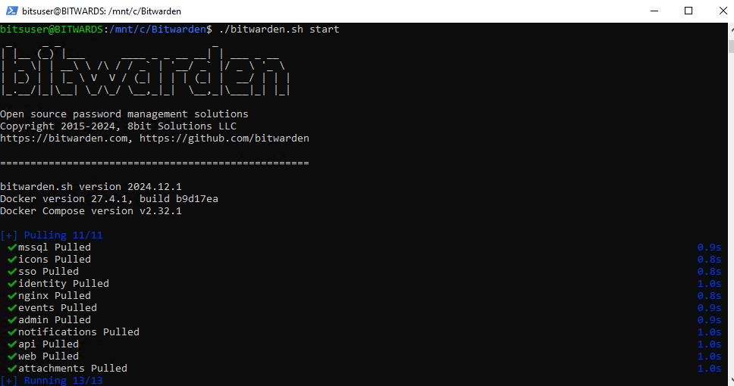

sudo vi /etc/init.d/start-docker

#!/bin/bash

### BEGIN INIT INFO

# Provides: docker

# Required-Start: $network $syslog

# Required-Stop:

# Should-Start: $network

# Default-Start: 2 3 4 5

# Default-Stop: 0 1 6

# Short-Description: Start Docker automatically

### END INIT INFO

sudo service docker start

Press ESC key

Type wq! <to safe the file>

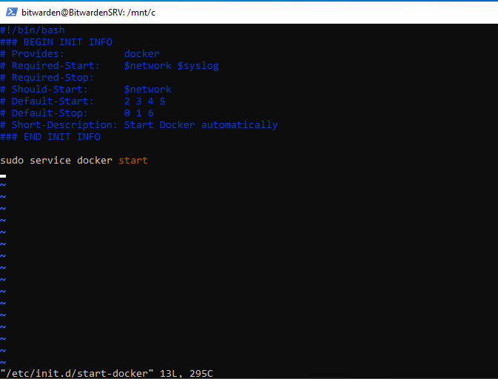

sudo chmod +x /etc/init.d/start-docker

sudo update-rc.d start-docker defaults

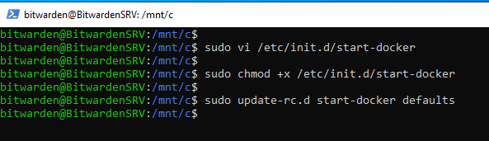

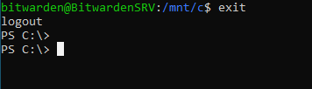

Restart the system to validate if Docker service is automatic started or not

Run the following command to verify if the Docker service is running or not

sudo service docker status

Before Running the Bitwarden Installation, Make sure the WSL (Ubuntu 20.04) is up & Docker service to be up.

Run the below two commands on the PowerShell

wsl -d Ubuntu-20.04

wsl --list --verbose

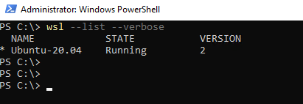

Check the Docker services

sudo service docker status

sudo service docker start

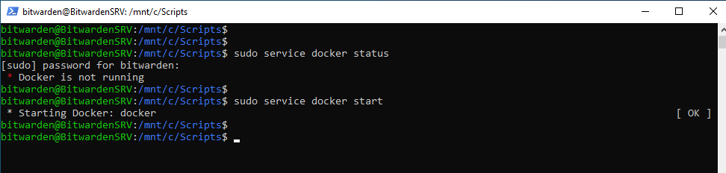

The System is ready for Bitwarden Installation

Navigate to the C:\Bitwarden directory

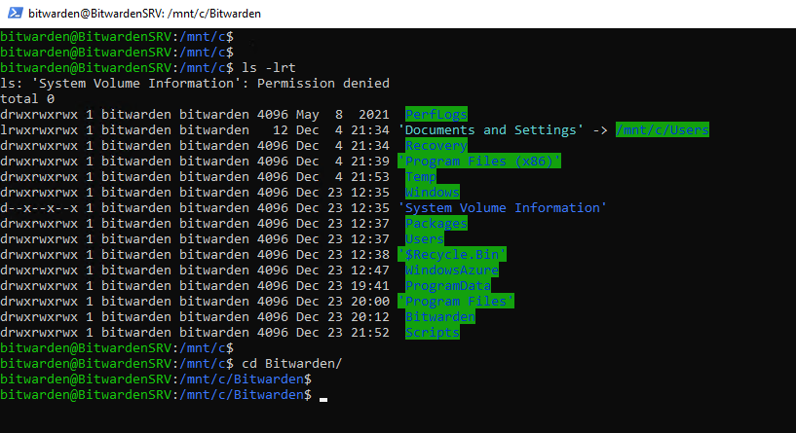

curl -L -o bitwarden.ps1 "https://func.bitwarden.com/api/dl/?app=self-host"

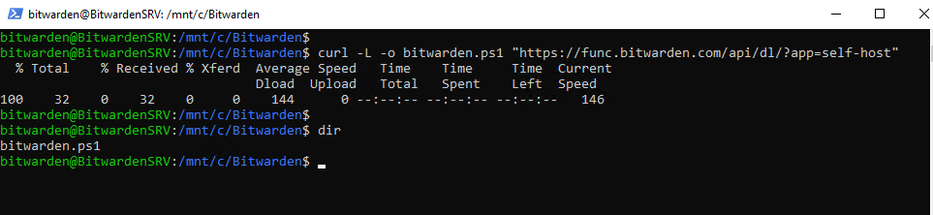

sudo apt update

sudo apt install -y wget apt-transport-https curl

# Download the Microsoft package signing key and add it to your system

wget -q "https://packages.microsoft.com/config/ubuntu/20.04/prod.list" -O /etc/apt/sources.list.d/microsoft-prod.list

curl https://packages.microsoft.com/keys/microsoft.asc | sudo apt-key add -

sudo apt update

sudo apt install -y powershell

pwsh --version



pwsh ./bitwarden.ps1

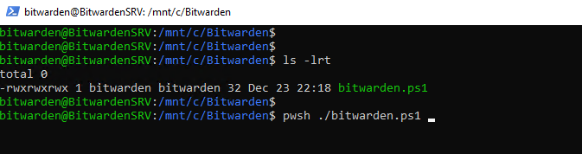

sudo vi ~/.bashrc

echo 'export PATH=$PATH:/usr/local/bin' >> ~/.bashrc

source ~/.bashrc

:wq!

pwsh ./bitwarden.ps1 -install

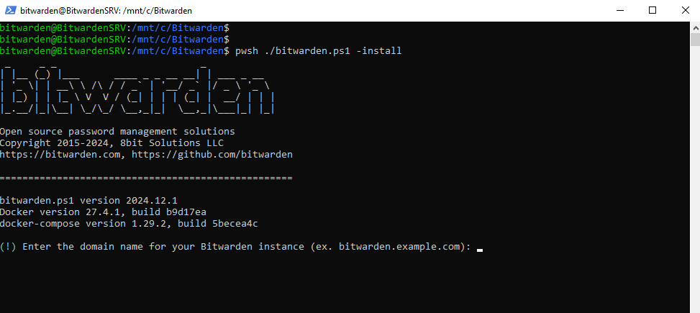

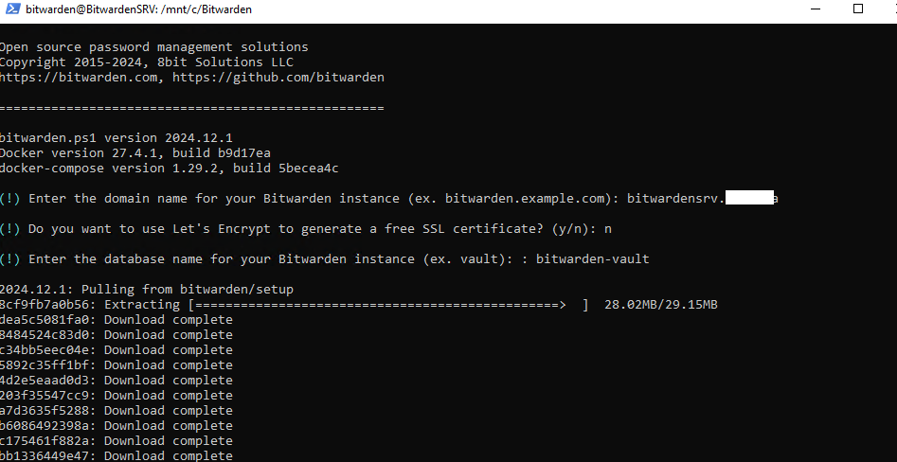

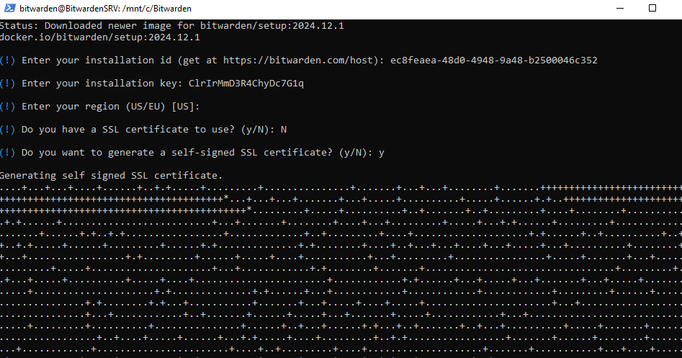

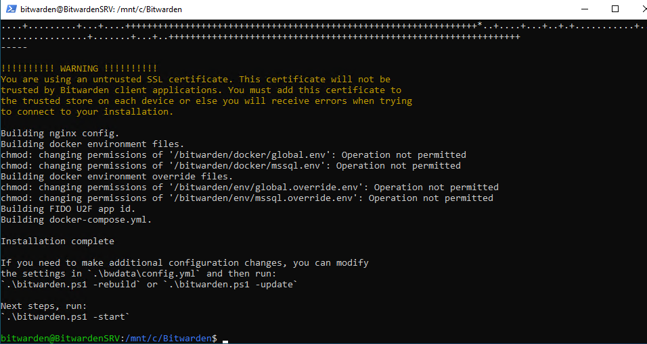

TRYING TO INSTALL BITWARDEN DIRECTLY ON POWERSHELL AFTER DOCKER START ON WSL (UBUNTU 20.04)

Invoke-RestMethod -OutFile bitwarden.ps1 -Uri <https://func.bitwarden.com/api/dl/?app=self-host&platform=windows>

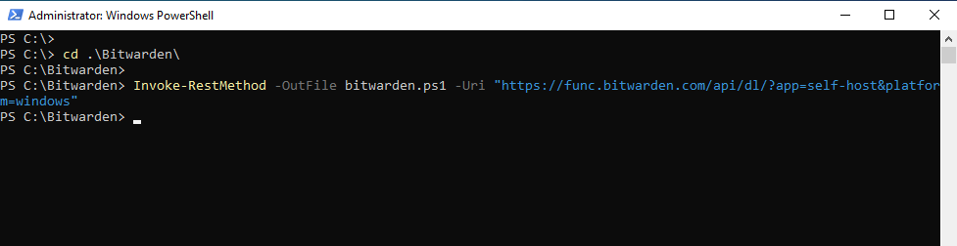

.\bitwarden.ps1 -install

